Project Design Phase-II
Data Flow Diagram & User Stories

Date | 16 February 2026
Team ID | LTVIP2026TMIDS48069
Project Name | Learnhub: Your Center For Skill Enhancement
Maximum Marks | 4 Marks

Data Flow Diagrams:
A Data Flow Diagram (DFD) is a traditional visual representation of the information flows within a system. A neat and clear DFD can depict the right amount of the system requirement graphically. It shows how data enters and leaves the system, what changes the information, and where data is stored.
Example: DFD Level 0

Example: (Simplified)
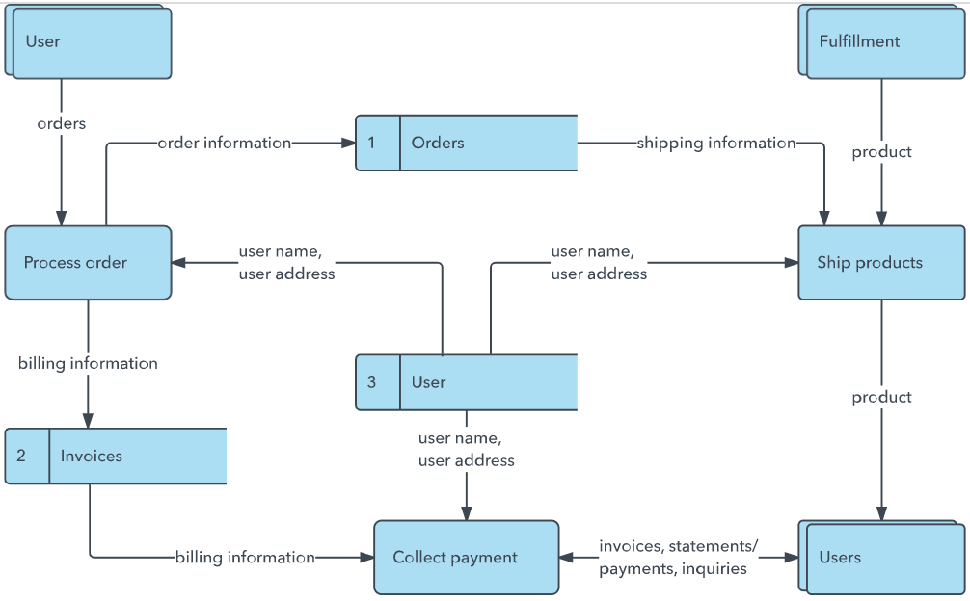


🔷 DATA FLOW DIAGRAM (DFD) – LEARNHUB
🔹 Level 0 DFD (Context Diagram)
External Entities:
• Student
• Instructor
• Admin
Main System:
LearnHub System
Data Flow:
- Student → Registers / Logs in → LearnHub
- LearnHub → Sends Confirmation → Student
- Student → Enrolls in Course → LearnHub
- Instructor → Uploads Course → LearnHub
- Admin → Manages Users & Courses → LearnHub
- LearnHub → Stores Data → Database
- LearnHub → Generates Certificate → Student

🔹 Level 1 DFD (Detailed Flow)
Process 1: User Authentication
Input: Registration details
Process: Validate & Store user data
Output: Account created / Login success
Data Store: User Database
Process 2: Course Management
Input: Course details from Instructor
Process: Upload & Save course
Output: Course available to students
Data Store: Course Database
Process 3: Enrollment & Learning
Input: Student enrollment request
Process: Grant access to course
Output: Course access + Progress tracking
Data Store: Enrollment Database
Process 4: Certificate Generation
Input: Course completion status
Process: Verify completion
Output: Generate digital certificate
Data Store: Certificate Records

🔷 USER STORIES – LEARNHUB

👨‍🎓 User Type: Student (Web User)

Functional Requirement (Epic) | User Story No | User Story | Acceptance Criteria | Priority | Release
Registration | USN-1 | As a student, I can register using email and password. | Account is created and dashboard is accessible. | High | Sprint-1
Registration | USN-2 | As a student, I receive a confirmation email after registering. | Confirmation email is sent successfully. | High | Sprint-1
Login | USN-3 | As a student, I can log in using email and password. | Successful login redirects to dashboard. | High | Sprint-1
Course Browsing | USN-4 | As a student, I can browse available courses. | Course list is displayed properly. | High | Sprint-1
Course Details | USN-5 | As a student, I can view detailed course information. | Course description and syllabus are visible. | High | Sprint-1
Enrollment | USN-6 | As a student, I can enroll in a course. | Course appears in my dashboard. | High | Sprint-1
Learning | USN-7 | As a student, I can watch video lectures. | Videos play without major errors. | High | Sprint-2
Progress Tracking | USN-8 | As a student, I can track my learning progress. | Progress bar updates correctly. | Medium | Sprint-2
Quiz | USN-9 | As a student, I can attempt quizzes. | Quiz score is recorded. | Medium | Sprint-2
Certificate | USN-10 | As a student, I can download course completion certificate. | Certificate PDF is generated successfully. | High | Sprint-3

👩‍🏫 User Type: Instructor

Functional Requirement | User Story No | User Story | Acceptance Criteria | Priority | Release
Course Upload | USN-11 | As an instructor, I can upload new courses. | Course is saved and visible to students. | High | Sprint-2
Manage Content | USN-12 | As an instructor, I can update course content. | Updated content reflects correctly. | Medium | Sprint-3
View Enrollments | USN-13 | As an instructor, I can view student enrollments. | Enrollment list is displayed. | Medium | Sprint-3

👨‍💼 User Type: Administrator

Functional Requirement | User Story No | User Story | Acceptance Criteria | Priority | Release
User Management | USN-14 | As an admin, I can manage student accounts. | Admin can activate/deactivate users. | High | Sprint-1
Course Approval | USN-15 | As an admin, I can approve uploaded courses. | Approved courses become visible. | High | Sprint-2
System Monitoring | USN-16 | As an admin, I can monitor system activity. | Dashboard shows usage statistics. | Medium | Sprint-3

✅ Final Outcome
This document defines:
• Data flow within LearnHub system
• Clear system processes
• Student, Instructor, and Admin user stories
• Functional priorities and sprint planning

